You Tour

Brd

Introduced by SE2018G08

Introduction

**Executive Summary**

Youtour site is a site that offers to a customer a huge number of trips which vary in price , hotels with different rate and the duration time. So users can find where to spend their time on holidays and enjoy it. The site will provide different ways of filtration to make it easy for users To get their point .

**Document Overview**

This document introduce You tour site study plan .It introduce general description, technical description, development plan.

**Business Objectives**

* Offer reservation of trips in easy way.
* Offer huge number of different trips.
* Offer filtration to choose the optimal offer from trips.
* Offer rating to the trip and its company .

Background

**Introduction**

Egypt is a country that is extremely rich in its historical background. With such a background it is easy to see why tourism is a big component of its gross national product. The well being of the Egyptian economy is highly dependent on a good year of tourism. The whole business of tourism has relied on the ancient monuments and relics of the past, but in recent years there has been a huge effort to create more modern tourist attractions like resorts and golf courses. The combinations of the old and new attractions comprise the biggest sector of the Egyptian economy. For the most part, it is said that Egypt consists basically of six different tourist sites. Three of the sites; Alexandria, Hurghada, and Sharm El Sheikh are coastal hotspots. They consist of many of the newer resorts offering many activities to its guests like water sports and golf courses. These three sites would be considered the more modern sites. The other three sites; Aswan, Cairo, and Luxor are the more historical tourist sites. Although Aswan doesn't hold that many historical monuments, the other two, Cairo and Luxor, are overflowing with them. These sites are highly geared towards the tourist and offer a wide variety of transportation and guided tours. Within a few of these sites are contained some of the most awe-inspiring and ancient monuments known to man. Now when you first hear the word Egypt, you directly focus your attention to the Great Pyramids of Giza. It is easily one of Egypt's most visited monuments and one of the world's largest tourist attractions. The ancient Greeks considered the pyramids to be one of the Seven Wonders of the World. Another one of the great monuments tocome out of ancient Egyptian society is the Sphinx. One of the greatest things about the Sphinx is that the purpose of it is still unknown and highly debated on. The Sphinx is known in Arabic as Abu El Hol, which means "Father of Terror"...

so In Egypt "land of civilizations" you tour web site will have the honor to help tourists to wander over all these places with having the best offer In terms of cost, stay and duration .Of course as known nowadays tourism is a good business to invest in, but marketin

for companies and attracting costumers can't happen perfectly without a website . You tour website will lead marketing for these companies . You tour will decrease number of manpower that have to market for the in Egypt .

On another hand costumer would like to have more than one offer and more than one trip to choose between .You tour will save time spent on searching for these trips.

**Survey**

Kadri Sylejmani’s and Agni Dika’sresearch (2011) suggests that the tourist life-cycle consists of 3 main phases:

* Pre-trip
* On-trip
* Post-trip

*For the* ***Pre-trip****phases: tourists plan* a lot for, booking accommodations, travel tickets, site visits, etc.

**Itineree:** online trip-advisor gives the user the freedom to choose the city, number of days, what to do & see and food. It gives mainly in each city stored in the website 3 main lists of suggestions for where to go & what to do, and food. These lists are the top 10 places, most recommended places and a browses list for all options. It has another option for those who don’t plan, already done plans by the website they make everything for you and you just “Pack your bag”.

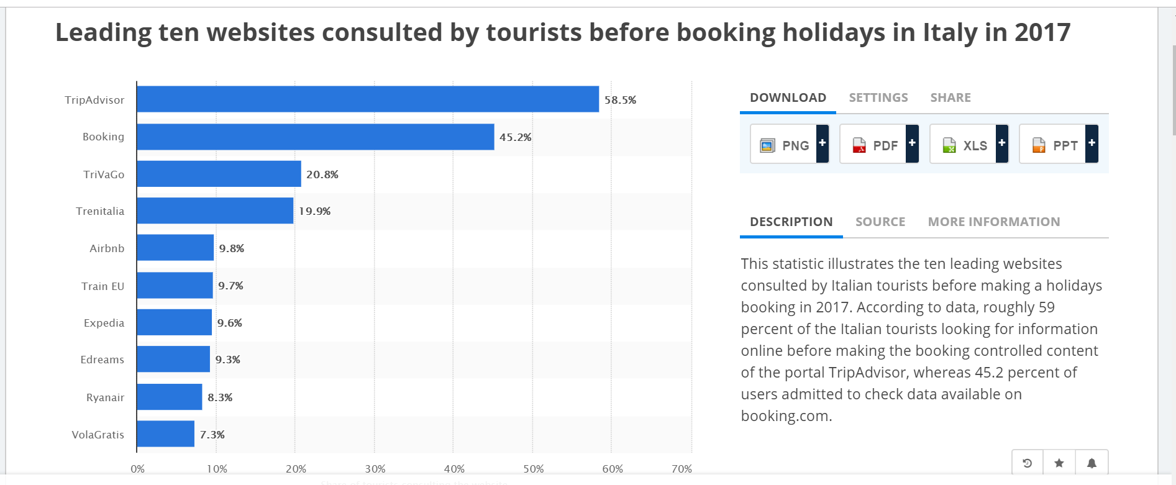

**TOP TOURISM WEBSITES**

[**Visit California**](http://www.visitcalifornia.com/): VisitCalifornia.com uses content to direct traffic to partner websites better than anyone. There’s also a ton of compelling video, such as the California Dream Eater series that bases its programming on crowd sourced social media recommendations.

[**Experience Columbus**](https://www.experiencecolumbus.com/)**:** Great on mobile and super fast, Columbus, Ohio’s tourism site highlights the city’s neighborhoods, festivals and events, and trendy food and beverage scene with a Millennial fetish for anything local and artisanal.

[**Discover Los Angeles**](http://www.discoverlosangeles.com/)**:** This website has a great map with in depth descriptions of each neighborhood to direct visitors through the city. The map also supports the groovy[Get Lost In L.A. campaign](https://skift.com/2016/04/05/skift-cmo-interviews-los-angeles-tourism-cmo-on-connecting-with-millennials/) designed to inspire visitors to explore neighborhoods beyond the iconic attractions.

[**Visit Dallas**](http://www.visitdallas.com/)**:** Visit Dallas wanted to better define itself among its competitive set in the leisure and meetings markets by profiling all of the different neighborhoods in the city. Launched last month, the new website has a big map high up on the home page that should be copied by every bureau.

[**San Francisco Travel**](http://www.sanfrancisco.travel/)**:** If ever there was a city that needs to define the individual character of its neighborhoods, it’s San Francisco. The website features good map functionality on the homepage, and there’s also [valuable Airbnb-supplied content](http://www.sanfrancisco.travel/search/site/airbnb) where hosts contribute their favorite local hangouts.

[**Keep Exploring Canada**](https://us-keepexploring.canada.travel/)**:**Destination Canada launched this new national tourism site in May 2016 as a breezy overview of what to explore among so many different provinces and territories. Brand USA should pay attention. The site is a good example of curating content for a wide area to drive traffic to individual regions.

[**Tourism Nova Scotia**](http://www.novascotia.com/)**:** This wins on design alone. Great professional photos and smart use of crowd sourced imagery. Map functionality allows you to search easily for specific activities like artist studio visits and upcoming farmer’s markets.

[**Chile Travel**](http://chile.travel/en/)**:** This is the best tourism website in Latin America, employing seamless navigation architecture to explore all of the different regions and myriad levels of sub-category content.

[**Colombia Travel**](http://www.colombia.travel/en)**:** A lot going on with this website. There’s a range of content here from fashion shows to flower fairs to Amazonian festivals that accurately depicts the energy behind the rise of Colombia into a global travel destination.

[**Visit Finland**](http://www.visitfinland.com/)**:** Your heart rate drops 10 points while exploring this site due to the ephemeral imagery. The [Tour de Relax](http://www.visitfinland.com/tour-de-relax/) is based on reality television travel races, except here you’re supposed to go slow.

[**Visit Stockholm**](https://www.visitstockholm.com/)**:** This colorful, high-energy site does a good job showing the vibrancy and variety in Sweden’s cosmopolitan capital. It’s very lifestyle focused with only three main categories highlighting: activities, culinary, and neighborhoods.

[**Visit Norway**](https://www.visitnorway.com/)**:** The long homepage gives you pretty much everything you need to plan a trip to Norway, which is especially helpful on mobile. The quirky [#SheepWithAView](https://www.visitnorway.com/sheepwithaview/) content series pinpoints the country’s identity.

[**Frankfurt Tourism**](http://www.frankfurt-tourismus.de/en)**:** This brand new portal takes the concept of visually-driven website design to the extreme on desktop. Super clean design on mobile. Succeeds in starting to shift the perception of Frankfurt as a financial capital into a more lifestyle experience.

[**Zurich Tourism**](https://www.zuerich.com/en#section-01): Intelligent site with unique geotag place-makers on photos to open new content, more cerebral travel content like the focus on Dada, and a great series of videos with locals discussing their jobs.

[**London & Partners**](http://www.londonandpartners.com/)**:** The tourism bureau has been instrumental in developing and promoting the London tech scene, and integrating that into travel and tourism promotion. An excellent example of collaboration between destination marketing and economic development.

**Tour & Trip Types**

## Sightseeing Tours

Sightseeing can be done in various ways, and although the most popular tends to be sightseeing by tour bus or coach, some companies offer sightseeing walking tours, like those through the streets.

Companies those offer sightseeing tours should provide some information to the customer like .

* Time : the exact date and time the buses moves .
* Place of the gathering.
* Detailed program for the trip.
* Type of transportation.
* The cost.

**Suggestion​​:**we suggest that companies limit this tours in duration to be not more 24 hours .

## Shore Excursion Tours

Shore excursions are offered as part of a cruise ship itinerary which can include river cruise ships, charter yachts, and other boats.

Companies those offer Shore excursions tours should provide some information to the customer like

* Time : the exact date and time the buses moves .
* Place of the gathering.
* Type of transportation.
* The cost.
* If this is a river or sea trip.
* It will be a ship or yacht or boats .

**Suggestion​​:**we suggest a limitation on age for customers how want this kind of tour for safety .

## Adventure or Sporting Tours

Adventure tours are extremely popular and provide people with an exciting way of travelling. Adventure and sports fanatics can enjoy tours catered to their individual skills and are led by a tour guide highly experienced in that particular sport.

**Suggestion​​:**we suggest that companies may provide a tour guide highly experienced in every sport.

## Combining Tours

Many week or month long tours can actually combinedifferent types of tours into one enjoyable experience.

Companies those offer Combining tours should provide some information to the customer like .

* duration : the exact date to go and the coming back date.
* The place of camping .

## Independent Vacation Trips

These vacations usually spend 2 or 3 nights in each location visited and usually only a few locations are visited. A tour guide is normally not included, but there is a usually a host available to answer questions and suggest sightseeing. Few meals and some sightseeing are typically included, but a lot of free time to explore is available. These vacations are ideal for independent travelers looking to set their own pace.

Companies those offer Independent Vacation trips should provide some information to the customer like:

* Number of rooms are valid.
* Number of customer per room.
* Number of meals per day.
* Type of meals.
* Rate of the hotel.
* The duration of trip.

**Suggestion​​:** we suggest that companies may offer discount for children & for large number of groups .

## Tour and Cruise

This is a tour or independent vacation that also has an accompanying cruise. The cruise is at least 3 nights or more. Tours with a one-day or overnight cruise are simply considered Escorted Tours.

**System Description**

**What is You tour**

When u decide to travel, u often get stuck in some questions like um ...where to go? Duration of stay? Plan? Which agency? Best offer? And of course If the place is worth visiting & if the company arrangements & services are pretty good! You tour website can answer those questions and provide different offers & plans matching different people desires & Budget.

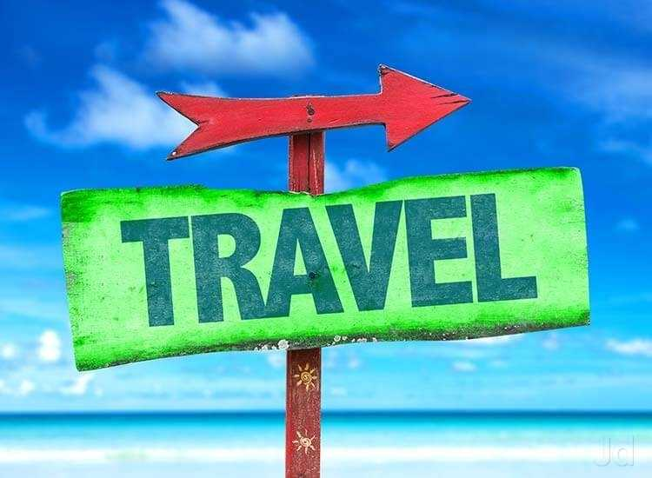

**Multiple offers**

**People needs are different coz of many things, to serve a wide range of customers, you tour main function is not just providing many offers, it also helps customers to choose which offers suit them better, by letting them add some info and after processing these info the website will show the suitable results .**

**Booking**

**-You tour makes communication with different agencies easier by providing their contacts (number, address ,their own websites (if exist) ,emails ,others).**

**-Special advantages for early booking.**

**Experiences sharing**

**You tour let you give your feedback and also see others feedback.**



System Architecture

You Tour system introduces huge amount of tour offers and many other services .The system offers the contents and service to both mobile and desktop users via web-based or dedicated mobile software.

The system consists of following modules: (1) Storage, (2) Data Processing, (3) Data Analytics, (4) Indexing, (5) Company Area, (6) General User Area, (7) Supervisors Area, (8) System Administration Area, (9)security.

storage

security

Data Analysis

indexing

Data Processing

Supervisors Area

Company Area

General user area

**Storage :**

The system uses different types of storage:

* Archive storage for historical changes, deleted contents and old logs
* System storage for system configuration, users information and fresh logs
* Indexing storage to support full text search engines

Archive storage uses JSON data format stored directly over distributed storage. JSON allow flexible access of data attributes. Distributed storage allow fast access of data items and offer expandable storage. Data replication is configured to minimum which full data availability and data recovery needs of archiving information

System storage uses traditional structured database which provide better queries and data processing over structured contents.

**Data Processing**

Data processing module is responsible on providing all data related services like data modeling and correction, data transformation, data classifier and multimedia processing.

Data modeling and correction is required to understand the textual material based on the related language model, this will allow better revision and improve the quality of Data transformation is required to allow import and export of different data format. The system supports common data formats supported by common data processors applications.

Multimedia processing is required to enhance the quality of multimedia contents like images. It converts multimedia contents to unified format. Also, this service is required to detect some features required by data classifier service.

Data classifier is required to classify the contents which is important to avoid

non-appropriate material.

The classifier uses information retrieved by data modeling and image processing services.

**Company Area**

Company area This module provides company with all tools required to build tours. Company can create, edit or delete tours. Company can view all saved tours listed by uploading date.

**General user area**

This module provides the user with tools required to choose the suitable tour. he can view all tours of all companies, he can filter the tours by the company, the cost, the most rated . also he can search for specific place. user can contact the company for booking the tour and rate it.

**Security**

Security module is responsible on user authentication and communications security. The portal access is made using https protocol in order to secure the communication Security module also, responsible on managing the permissions and roles. Users are either guests logged users , responsible on detecting the threats and preventing data theft.

**System Features**

**Provide Offers from different companies**

The system will be able to provide various offers for different travel and tourism companies. Instead of browsing the packages and offers of just one travelling agency, the user will have the opportunity to go through a larger number of offers without the effort of going into each company's website. The system will show the results that match the criteria that the user stated in the search/filtering process and then they will scroll through all the suitable offers and choose the one that fit them the best.

**User Search and filtering**

The user can search and filter through all the offers to narrow down the options. The user can filter by three criteria. First one is filtering by the place they want to go to (e.g. Alexandria or Hurghada) then the system will get all the offers for that chosen place. The second one is by the cost of the package as a whole. The user can enter a range of cost that suits them and the system will provide them with offers within that range. The last one is filtering by the date/timing of the trips. The user can search using one or all the filters to facilitate the searching process.

**Detailed Description Of The Offers**

The system provides a very detailed description for every offer so that the user can know all the information from our system and won't feel obliged to contact the companies for more information. The description includes the place they are going to visit, the program of the trip, its duration, the hotel and its rating, the available activities at that place, the transportation details (if the transportation is provided), the cost of the trip. It will also include any further details that the travel agencies provide regarding any trip.

**Easy User Access**

The user doesn’t have to register to access this information. They only need to go through the website and start exploring and searching for their best options.

**User Profile**

Users are either companies or customers. companies contribute to the system by providing their tours schedule ( each tour plan and description ) and their contacts .Customers browse the companies offers and he can book using his account (onlyregistered user can use initial booking and rate options ) .customer profile will view his special offers and discounts ,company

Profile will view its offers and trips.

**Booking**

The system provides with each offer/trip the contact information (mobile number, email, website and location) for the travel agency so that when the user decides on a specific offer, they can contact the agency and book the offer they want.

The system provides also initial booking ,but if the customer doesn’t confirm it ,it will be cancelled.

**Updates**

The system will get updated frequently so that the user can always find the latest offers whenever they search.

**Show Best Offers**

The system provides the option to look at the best offers first before searching so that it's easier for the user to find what suits them best before exploring all the other options.

**Rating**

Users can rate their experiences with the system and the tour offers.

# System Development

## Overview

The system development is performed using agile methodology. Initial R&D activity should be applied to write the BRD and SRS and SDA. Then, system development activities start. The final release of the system should take four months.

## Development Plan

|  |  |  |  |  |  |  |  |  |  |  |
| --- | --- | --- | --- | --- | --- | --- | --- | --- | --- | --- |
|  | 1 | 2 | 3 | 4 | 5 | 6 | 7 | 8 | 9 | 10 |
| BRD |  |  |  |  |  |  |  |  |  |  |
| studying |  |  |  |  |  |  |  |  |  |  |
| Prototype |  |  |  |  |  |  |  |  |  |  |
| modifications |  |  |  |  |  |  |  |  |  |  |
| Final Release |  |  |  |  |  |  |  |  |  |  |
| deliver |  |  |  |  |  |  |  |  |  |  |

## Development Plan

**Team**

|  |  |
| --- | --- |
| Names | **Role** |
| Israa Mahmoud Awad | * back– end * Back – end testing * documentation |
| Hossam Mahmoud | * Back – end * documentation |
| Mohamed Abdelsalam | * Back – end * documentation |
| Mahmoud Hafez | * Back– end * Back_end testing * documentation |
| Ahmed Ashraf | * Front – end * Front _end testing * documentation |
| Yara Alaa | * Front – end * documentation |
| Sara Hanfy | * Front_end * Front_end testing * Documentation |
| Mostafa shaaban | * Front _end * Front_end_tester * Documentation |
| Geo Nabil | * Front – end |
| Shady Shebl | * Front – end |

## Tools

Youtour site will be developed using open source tools, languages and servers. Commercial tools will be used in case there is no open source alternative. This will decrease the cost especially for long term operation.

|  |  |
| --- | --- |
| Operation | Recommended Tools |
| Source Control and Versioning | GitHub/Git |
| Tasks and Issues Tracking | GitHub/Git |
| Programing Languages | python, JavaScript |
| Operating Systems | Windows 10 |
| Documents | Microsoft word/Excel |
| framework | Django 1.9.1 |
|  |  |

## Infrastructure

Youtour site system requires multiple infrastructures for development.

|  |  |  |
| --- | --- | --- |
| Typ | Name | # |
| Development Infrastructure | Online hosting Server (Virtual),  Supports python and MySQL | 1 Server |
| Online Backup Storage | 10 TB |

**Cost**

● free tools

## Assumptions

* The system completely depends on companies’ contribution by providing tours
* The system completely depends on free open source tools and languages.

## Limitations

* The system does not provide any online payment options. It may only contain an external link to trip organizer site or their contact information.

## Risks

## Lose users trust because of lack of protection systems to secure the site.

## References

## 

## url: <https://www.jobmonkey.com/landtours/types_of_tours/>

## url:https://www.affordabletours.com/search/Type/